OriginatorS
Name | Job Title | Signature | Date
Brian Cullinan | Software Developer
Lloyd Kurth | Senior Software Architect
Approvals
Name | Job Title | Signature | Date
Scott Pletzer | Director of Quality & Program Management
Andrew Mason | Chief Technology Officer
Revision History
Revision | Revision Date | Reason for Revision/Change Request | Revised By
000 | 18-May-12 | Initial Release | S. Pletzer
001 | 31-Aug-12 | Complete rewrite. | L. Kurth

Purpose
The purpose of this document is to define the overall system requirements for the EPIC Central component of the ClearView solution. EPIC Central is the name of the ClearView SaaS-based solution to be used for the following purposes:
- Registration and authentication of ClearView devices
- Authorizing the ability for devices to perform scans
- Archiving of scan images and analysis data
- Viewing archived scan images and analysis results, including full search functionality
- Administration of customer, partner and user accounts
- Purchasing of additional scans
- Device management and status tracking
- Administrative messaging; send messages to any group of devices
- Support center for issue tracking and resolution
- Exception tracking and notifications

Scope
This document contains the functional requirements for the initial release of the EPIC Central system. It does not specify requirements for any other system, but it does specify requirements for how it interfaces with other systems in the EPIC ecosystem. These requirements will be augmented for subsequent releases of EPIC Central.

Definitions
Administrator | Either a Service Administrator or an Organization Administrator; see those definitions below.
API | Application Programming Interface. An interface specification for access to a software service implementation.
Atomic Transaction | A related set of database operations that either all occur or nothing occurs.
Device | A device is a ClearView device, more specifically the ClearView scanner along with its host PC running the ClearView application. To be able to operate, a ClearView device must communicate with EPIC Central. A device must be configured with EPIC Central before it can become operational.
Ecosystem | The worldwide combination of the EPIC Central service and all managed ClearView devices.
EPIC Central | The SaaS system being built. This term will usually refer to the custom software being developed. In certain contexts, it may refer to more, such as the operating system along with the standard server components, or it may also include the hardware on this it runs.
HTTP | The predominate and ubiquitous Internet protocol for accessing remote servers via a web browser.
HTTPS | HTTP through an SSL/TLS tunnel. Allows strong encryption of all data transmission with server authentication while remaining fully transparent to web application and user.
Location | An organization’s place of business. A single organization may have multiple locations where it conducts business.
Organization | A legal entity with which EPIC has a business relationship, either directly or indirectly, and whose personnel need the ability to use EPIC Central.
Organization Administrator | A pre-defined role assigned to users who have administrative rights for a particular organization. This term is used throughout this document to refer to any user in this role.
Role | Defines a set of privileges/permissions used to manage access to system functions. A user assigned a particular role has the privileges defined by that role.
SaaS | Software as a Service. A model for software applications which are hosted on servers in the Internet cloud and accessed with a thin client or through an API such as a web service.
Service Administrator | A pre-defined role assigned to user who have full administrative rights for the entire EPIC Central system. This term is used throughout this document to refer to any user in this role.
SSL/TLS | Secure Sockets Layer/Transport Layer Security. Provides an encrypted tunnel over a public network through which many other protocols, such as HTTP and FTP, can operate transparently. TLS is the current specification and replaces SSL, but the SSL acronym is still widely used.
Treatment | The record of a scan. This term is used interchangeably with “scan” and is kept to maintain continuity with the terminology of the ClearView application.
User | A person that can log in to use EPIC Central. This person may be either an EPIC employee, or a person associated with another organization with a business relationship with EPIC, such as a customer using a ClearView device.
User Account | A record, maintained with the database, of a user. A user account contains a unique user name which identifies the account. It also contains other information about the user, e.g. first name, last name, email address, and information about the user’s activity.
Web Service | An application programming interface (API) implemented and running as a service on a server that can be invoked by a client via the network.

System Requirements
The following figure illustrates the general configuration of an EPIC Central ecosystem.
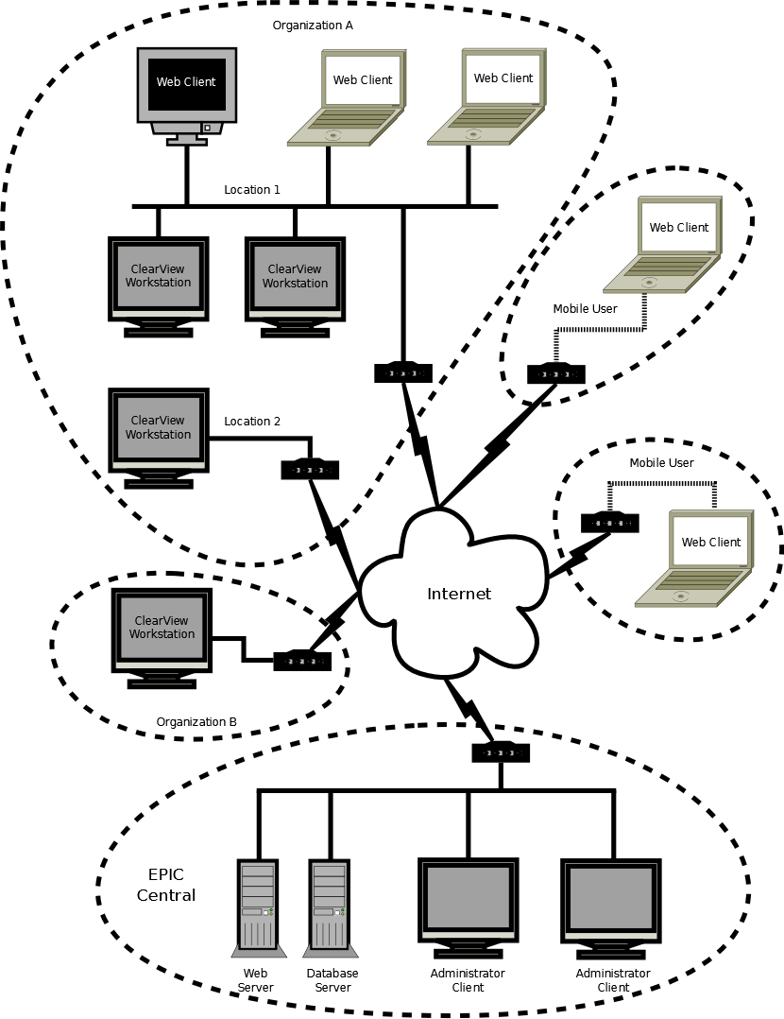
The ecosystem consists of the EPIC Central site connected to multiple end-user organizations via the Internet. Each organization will have one or more locations, and each location one or more ClearView devices. In addition, EPIC Central is accessible from any web browser client connected to the Internet.

Configuration
The configuration of EPIC Central includes all the various entities needed for the environment in which ClearView devices are able to operate and be managed effectively.

Organizations

Two types of organizations must be supported: 1) a Host, and 2) an End User.

The design should accommodate the addition of other types of organizations in the future.

There must be one and only one Host organization; the Host organization will be EPIC.

Creation of new organizations must be restricted to Service Administrators.

A Service Administrator must be able to change the name of an existing organization.

An Organization Administrator must be able to change the name of his/her own organization.

Locations

A location must have a name.

A location should have a mailing address and telephone number.

A Service Administrator must be able to create or edit a location for any organization.

An Organization Administrator must be able to create or edit a location for his/her own organization and only that organization.

A Service Administrator must be able to edit the geocoding information (latitude and longitude) for the location.

EPIC Central should provide an automated lookup for geocoding information using the mailing address of the location.

Devices

A device must be configured with EPIC Central before it can become operational.

A Service Administrator must create/modify a device. No other role has rights to create or modify the configuration of a device.

A device must be assigned to one and only one location.

A device must have a serial number; this is required to register the device with EPIC Central.

A device must have a revision level.

A Service Administrator may set the number of scans available when modifying device configuration.

When modifying the number of scans available, a Service Administrator must provide notes that track the reason for the modification.

When the number of scans is modified, a record of the action must be created in the purchase log.

Users

Any person needing access to EPIC Central must have a user account. (We cannot prevent multiple persons from sharing a single user account although this practice will be discouraged.)

User Account Creation
Since EPIC Central is not generally available to the public, user accounts will be tightly controlled and only provided to known persons who need access.

A user account must be created by an administrator.

A Service Administrator must be able to configure a user account for any organization.

An Organization Administrator must be able to configure a user account for his/her own organization only.

When a user account is created the following data is required: 1) the user’s first name, 2) the user’s last name, 3) the user’s valid email address, 4) the user’s role, 5) the organization to which the user will be assigned, and 6) the location(s) within the organization to which the user will be assigned.

EPIC Central must validate that the administrator has provided all necessary entries for creation of the user account.

EPIC Central must validate that the email address provided meets the format of a valid Internet email address. (EPIC Central cannot determine if the email address actually exists.)

When all user entries are valid, EPIC Central must create a user account for the user. This account must not be usable until the user completes the registration process; see section 4.1.4.3 User Registration.

After successfully creating a user account, EPIC Central must notify the user that an account has been created at the valid email address for the account.

The notification email must include information unique to the newly created account which the user can use to complete the account setup process.

User Registration
User registration is the process by which the user completes the account setup process, creating a user name and password for the account.

The user must connect to EPIC Central to complete the registration process.

The user must provide the unique information found in the notification email received in order to complete registration.

The user must choose a user name that meets the criteria for valid user names and which is unique to EPIC Central; see section 4.7.1 Format Restrictions. The user may use his/her email address as a user name.

The user must create a password for the account that meets the criteria for valid passwords; see 4.7.1 Format Restrictions.

The user must re-enter (confirm) the password. This confirmation entry must match the first-time entry of the password.

EPIC Central must validate that the user name entered is valid and unique across all users of EPIC Central.

EPIC Central must validate that the password entered is valid.

EPIC Central must validate that the re-entered (confirmed) password entry matches the first entry of the password.

If any user entries are invalid, EPIC Central must inform the user of the invalid entries and allow the user to make corrections.

When all user entries are valid, EPIC Central must fully initialize the user account and log the user in.

Roles

The ability to view or change data must be based on the assigned role of a user.

A user must be assigned to one and only one role.

Defined Roles
Roles will be defined herein (by requirements) and designed and implemented accordingly. There will be no ability to modify roles through the user interface.

At a minimum, three roles must be defined: 1) Service Administrator, 2) Organization Administrator, and 3) Simple User.

The Service Administrator role must not be restricted to any single organization.

The Organization Administrator role must be restricted to administration of the user’s only assigned organization.

The Simple User role must be restricted to administration of the user’s own personal settings.

Role Assignment

A role must be assigned to a user by an administrator.

A Service Administrator must be able to assign any role to any user.

An Organization Administrator must be able to assign the Organization Administrator role or Simple User role to any user in his/her organization.

A Simple User must have no ability to assign a role to himself/herself or any other user.

A role must be assigned to a user when the user’s account is created.

An administrator must be able to change a user’s role at any time, either before or after the user completes the registration process.

Any change to a user’s role must take effect on the next action performed by the user.

System Settings

At any time, a Service Administrator must be able to disable or re-enable the ability for devices to access EPIC Central.

Scan Rates

A Service Administrator must be able to create a rate structure for the purchase of scans.

A rate structure will consist of multiple price points, each with a quantity range (minimum and maximum quantity) and a cost per scan when the quantity purchased falls in that range.

Each price point must have an effective date, the time after which the rate is effective.

Basic User Functions
These are normal day-to-day functions users may perform.

Authentication

All users must log on (authenticate) with a user name and password.

Every new web browser session must require the user to authenticate. No persistence of the user name or password across sessions will be allowed.

A log-off function must be provided so the user can log off and prevent unauthorized access by another person.

When the user logs off, the user’s session must be cleared.

An authenticated user’s session must time out and be automatically cleared after 60 minutes of inactivity.

Operations
This function provides a view of activity in the ecosystem with updates reflected in near real time.

This function must be restricted to Service Administrators.

The following daily counts should be displayed 1) scans performed, 2) total purchase amount, 3) currently active devices, 4) exceptions reported, and 5) support requests submitted.

The following aggregates should be displayed: 1) total scans, 2) total purchased, 3) total devices in EPIC Central, 4) total active users, and 5) total active organizations.

The user should be presented with a geographical world map with each device’s location on the map presented with an icon.

Each icon should identify the most recent of the following activities that occurred on that device: 1) purchase made, 2) ping (presence), 3) scan started, 4) scan completed, 5) calibration performed, and 6) support request submitted.

The user must be able to pan the map to bring different areas into view.

The user must be able to zoom in and out on the map.

When the user clicks an icon on the map, a pop-up will display the device’s status and its location.

Patients

A user must be able to view patient records for any patient scanned with a device within the organization the user is associated with.

At a minimum, patient records must be searchable by: 1) first name, 2) last name, 3) treatment time (date), and 4) location where treatment occurred.

A Service Administrator must be able to view/search any patient record in EPIC Central.

A user must be able to view any or all treatments for any patient the user is able to view.

Treatments

A user must be able to view treatment records from any device within the organization the user is associated with.

At a minimum, treatment records must be searchable by: 1) first name, 2) last name, 3) treatment time (date), and 4) location where treatment occurred.

A Service Administrator must be able to view/search any treatment record in EPIC Central.

The view of a treatment should be modeled after the way a treatment is presented on the device since users will use both interchangeably.

Purchases

Credit Cards

EPIC Central must interface with an external, third-party payment gateway, such as Authorize.Net, for processing credit card transactions.

EPIC Central must not store any usable credit card information. Full credit card records should be maintained by the payment gateway.

EPIC Central may store a small subset of the credit card number (last 4-digits) to be able to allow a user to select one of several credit cards to use.

EPIC Central may store, and present to the user, the name on a credit card and part of the billing address, e.g. the street address.

When using a credit card for the first time to make a purchase, the security code (CCV) is required.

After the initial purchase with a credit card, subsequent purchases may be made with the combination of information stored by EPIC Central and that stored by the payment gateway.

Making Purchases

A user should be able to make purchases for any device in any location he/she is assigned to.

An Organization Administrator should be able to make purchases for any device in any location of his/her organization.

When a purchase is complete, the number of scans available for a device will be increased by the number of scans purchased.

Scans available to one device must be transferrable to another device within the same organization.

A log of purchases and transfers must be kept. Any time a purchase is made or a transfer performed, a log entry must be made to record the action.

At a minimum, the log must be searchable by: 1) time (date) of purchase/transfer, 2) device, 3) location, and 4) number of scans.

Password Management

Authenticated Password Change

The ability for an authenticated user to change his/her password must be provided.

When changing a password, EPIC Central must require the user to enter 1) his/her current password, 2) a new password, and 3) a re-entry of the new password.

EPIC Central must validate: 1) the current password matches the user’s current password, 2) the new password is valid, and 3) the re-entered (confirmed) password matches the first entry of the new password. If any validation fails, EPIC Central must reject the user’s request with an appropriate error message.

On successful completion, a password change must take effect the next time the user logs in.

Forgotten Password Reset

EPIC Central must provide a method for a user to reset his/her password if it is forgotten.

The user must provide the email address for the account to be reset.

The user may provide the user name for the account to be reset; if the user has more than one account with the same email address, this will restrict the reset to that one account.

EPIC Central must send an email to the email address of the account that is reset.

EPIC Central must restrict the account so it cannot be used until a new password is provided.

If the user has multiple accounts with the same email address and does not specify a user name to identify a specific account, all accounts with that email address must be restricted until the user resets the password for one of the accounts.

Using the information provided in the email, the user must come back to EPIC Central to reset the password.

EPIC Central must allow the user to enter and re-enter (confirm) a new password.

On successful completion, the new password must take effect immediately.

Device Management

Device Registration

A device must be registered with EPIC Central before it can perform scans and be fully operational.

The registration process must be performed for any new device or any device being moved from one location to another location.

The device registration process must be performed by a user known to EPIC Central; the user must have a user account and be able to authenticate with EPIC Central.

During registration, the device must be assigned to one and only one location.

The location to which a device is assigned must be a location associated with the same organization as the organization of the user performing registration.

The user must provide the serial number of the device being registered.

When registration is completed successfully, the device must be fully operational.

Device Control

A Service Administrator must be able to add a new device to EPIC Central.

A Service Administrator must be able to set the state of a device so it can be re-registered. (There may be many reasons for this. One is if the device is being moved.)

A Service Administrator must be able to lock a device so it cannot be used for scans.

A Service Administrator must be able to unlock a locked device.

A Service Administrator must be able to permanently take a device out of service.

A device that must be re-registered must not be allowed to perform scans.

A device that is locked must not be allowed to perform scans.

A device that is permanently taken out of service must not be allowed to authenticate with EPIC Central.

Support
Online support allows users to request help and support personnel to respond or proactively send messages to users.

Support Requests

Any authenticated user must be able to create a support request.

When a support request is created, it must result in a message sent to a designated support address.

A support request should have at least the following: 1) a subject, 2) a list of recipients, and 3) a message body.

A recipient of a message must be able to respond to the message with another message.

A user must be able to view all their support requests and responses to those requests.

A user must be able to remove messages when he/she determines that are no longer useful.

When a support request is made, the Operations view should update automatically to indicate the request has been received; see section 4.2.2 Operations.

Administrative Messages
Administrative messages are general notices that can be sent to devices. These messages will then be displayed by the ClearView application.

Administrative messages can be created and sent to any device, location or organization.

A message designated for a location, must be sent to every device at that location.

A message designated for an organization, must be sent to every device in that organization.

A message should be delivered to a device only once.

A message can be changed any time before it is delivered.

A message can be removed any time before it is delivered.

The ability to create, change or remove messages must be restricted to Service Administrators.

Diagnostics

Exceptions
Exceptions are uploaded when they occur on devices. They can be viewed by a Service Administrator to diagnose device issues.

Exceptions uploaded from devices must be viewable only by a Service Administrator.

The exception view should include the following details: 1) device serial number, 2) exception message, 3) exception stack trace, 4) machine name, 5) currently authenticated user on the device when the exception occurred, 6) machine operating system, 7) application version, and 8) time when exception occurred.

At a minimum, exceptions must be searchable by: 1) device, 2) location, 3) exception message, and 4) time when exception occurred.

Logging

All application exceptions that occur on EPIC Central should be logged.

All actions and events that occur should be logged for traceability.

Web Services
A set of web services running on EPIC Central allow a device to interact with EPIC Central in an automated way with little or no manual user intervention.

A web service must be provided for each of the following functions:

Registering a new device.

Re-registering an existing device.

Resetting device authentication credentials.

Validating the licensed ability to perform a scan.

Requesting the number of scans available for the device.

Reporting the completion of a scan.

Adding a patient record.

Updating a patient record.

Adding a calibration record, including the set of calibration images.

Adding a scan (treatment) record, including the set of images and all analysis data.

Requesting administrative messages queued for the device.

Adding an exception record.

Reporting status including: 1) scan start, 2) scan end, 3) calibration start, 4) calibration end, 5) device application start, 6) device application end, and 7) presence (ping).

Every service invocation must be authenticated. If authentication fails, access must be denied.

During registration of a device, authentication must be performed with a user name and password since the device is not fully functional.

After registration, the device must authenticate itself.

Device authentication must be highly secure, e.g. an encrypted shared secret.

EPIC Central must track the number of scans available for a device and decrement the count when the device reports the completion of a scan.

An administrative message should be delivered to a device only once.

Operations which add or update data must be performed as atomic transactions.

Data

Format Restrictions

A user name must be between 8 and 80 (inclusive) characters in length.

A user name must not contain a space character.

A user password must be between 8 and 24 (inclusive) characters in length.

A user password must not contain a space character.

A user password must contain at least one character from 3 of these 4 character groups: 1) lowercase letters, 2) uppercase letters, 3) numeric digits, and 4) symbols, e.g. @, $, #, etc.

Uniqueness

Every organization, location and device must have an ID that is guaranteed to be unique across the ecosystem.

EPIC Central must guarantee that IDs assigned to data records by a device are unique across the ecosystem.

Lifetime

Data that provides an auditable history of the operation of EPIC Central must not be deleted.

Data records no longer required for the operation of EPIC Central should be marked as no longer active; they must not be deleted.

Interfaces

Security

Access from the public Internet must be limited to HTTPS.

Access to the system console must be limited to the local network.

Access to the system console must be limited to Windows users who are administrators.

Browsers

Internet Explorer (IE) version 9.0 and above must be supported.

Mozilla Firefox version 11 and above must be supported.

Google Chrome version 18 and above must be supported.

Apple Safari version 5.1 and above must be supported.

Internationalization/Localization

The web user interface must be internationalized using standard techniques to allow for consistent and straightforward localization.

The web user interface must be localized for US-English.

A web user must be able to select a specific localization based on his/her current location or with a user setting.

The localization setting must default to US-English if the user’s selected localization does not exist.

Error Handling

User entry errors should be detected as early as possible.

Error messages should be presented to the user in a clear and consistent manner.

Wherever possible, error messages may include hints about how to correct errors.

General

The style (colors, layout, etc.) of the EPIC Central web interface must be consistent with and complement the style of the EPIC corporate website.

A link to the EPIC corporate website must be provided on any page of EPIC Central where an unauthenticated user may land.

Presentation of all facets (menus, lists, labels, input fields, dialog, buttons, links, etc.) of the user interface should be consistent.

Functions unavailable to a user based on the user’s role (rights) must not be presented to the user.

